Sara White
CSD-430
Assignment 5.3/6.3 Screenshots

Page display with drop down menu/button submission:


Selecting a movie ID from the dropdown menu:
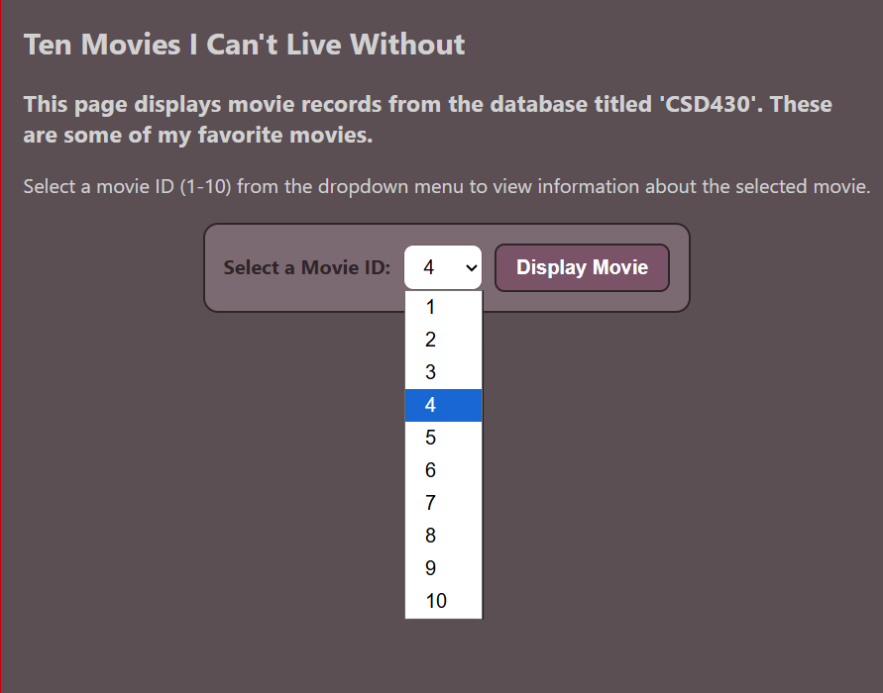

Display after selecting a movie ID (in this example, movie ID 4):
